**Installation of OpenDayLight in AWS**

**STEP1 Create an AWS EC2 Instance**

<http://docs.aws.amazon.com/AWSEC2/latest/UserGuide/LaunchingAndUsingInstances.html>

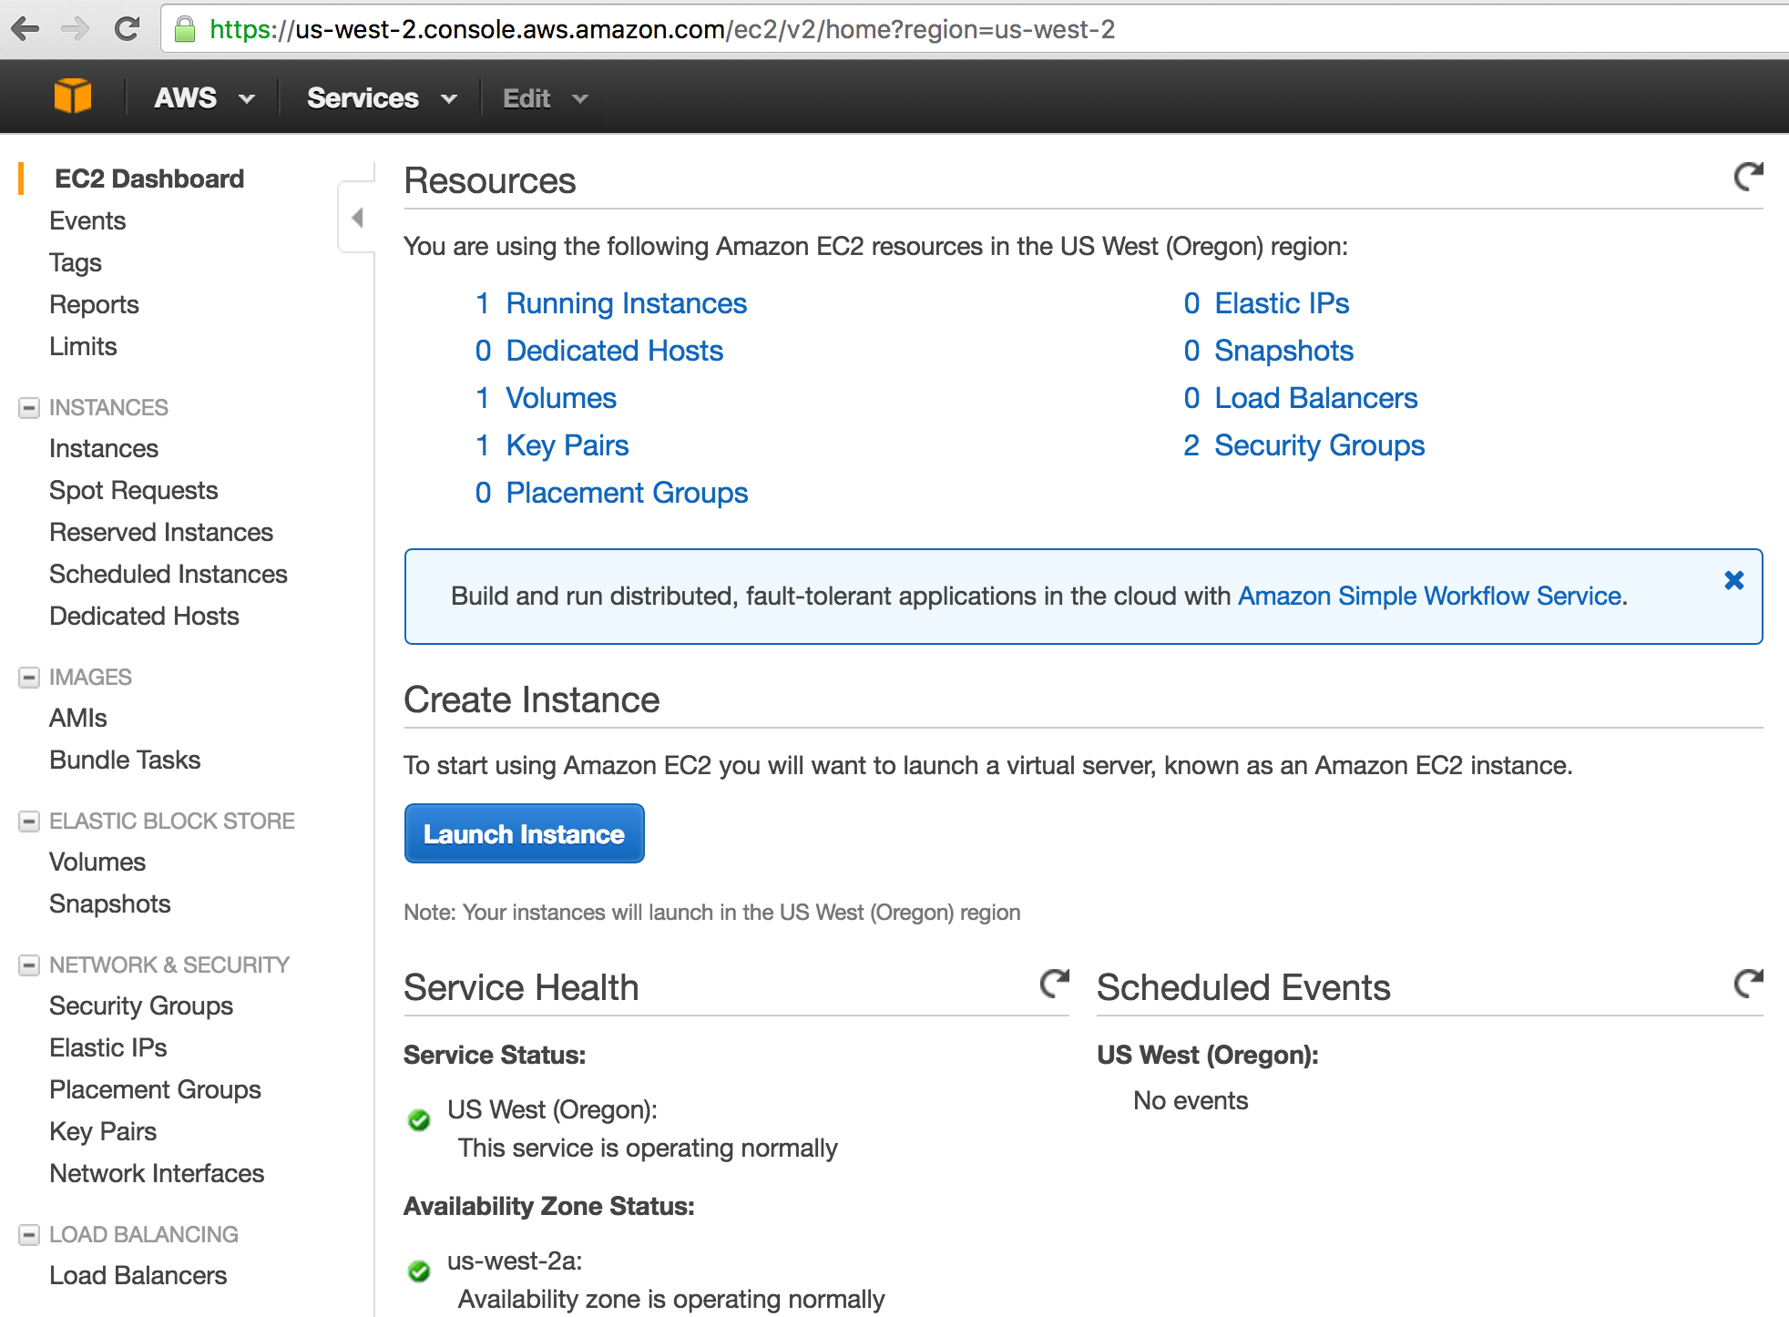

Since you are using AWS, make sure your security groups are allowing access to 8181

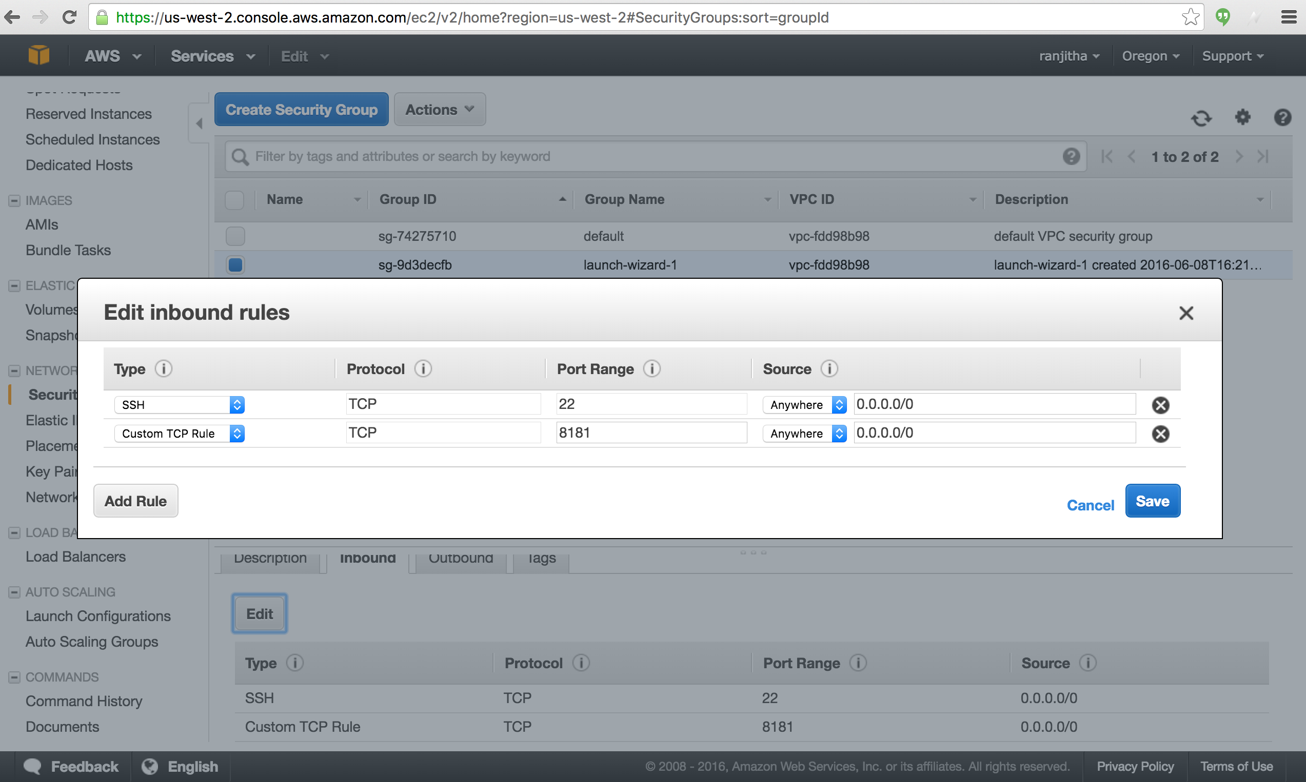

<https://www.opendaylight.org/software/downloads/lithium>

Download your PEM key in your local directory

**STEP2 Launch your EC2 AWS instance**

Use the following command to start your EC2 instance

ssh -i XXXX.pem ubuntu@INSTANCE_NAME

EXAMPLE:

ssh -i odl_new.pem [ubuntu@ec2-54-218-83-250.us-west-2.compute.amazonaws.com](mailto:ubuntu@ec2-54-218-83-250.us-west-2.compute.amazonaws.com)

STEP3 Downloand and run opendaylight controller

wget <https://nexus.opendaylight.org/content/groups/public/org/opendaylight/integration/distribution-karaf/0.3.0-Lithium/distribution-karaf-0.3.0-Lithium.zip>

unzip distribution-karaf-0.3.0-Lithium.zip

cd distribution-karaf-0.3.0-Lithium/bin

sudo ./karaf

opendaylight-user**@**root>feature:install odl-dlux-all odl-restconf-all odl-l2switch-switch

opendaylight-user**@**root>feature:install odl-aaa-authn odl-restconf odl-mdsal-apidocs odl-l2switch-switch

**STEP3 Download and run mininet**

Start another instance of EC2 and run your mininet

<http://mininet.org/download/>

sudo mn --mac --topo single,3 --controller remote --switch ovsk,protocols=OpenFlow13

pingall

**STEP4 View the UI of ODL-DLUX**

To access the DLUX

<http://ec2-54-218-83-250.us-west-2.compute.amazonaws.com:8181/index.html>

US: admin

PWD: admin

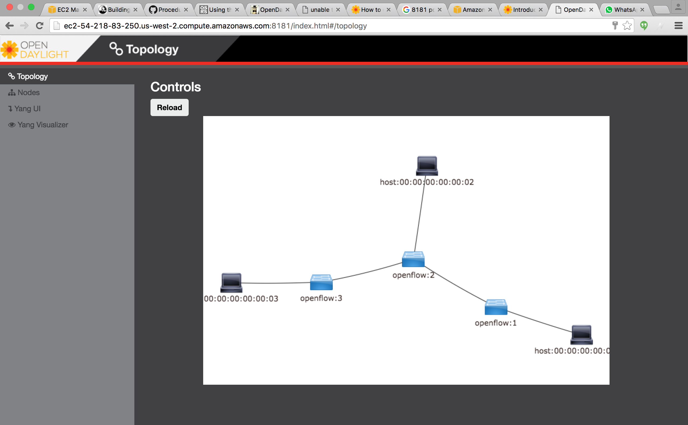

Commands to see if the process is running

Ps –ef|grep karaf

Ps –ef|grep mn

To clean up mininet sudo mn -c

Command to check if the controller is running

sudo netstat –tanp